Chapter 6, Solution 64.

- When the switch is in position A,
i= –6 = i(0)
When the switch is in position B,

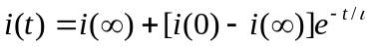

i(t) = (3 – 9e^{–8t}) A

- -12 + 4i(0) + v=0, i.e. v = 12 – 4i(0) = 36 V

- At steady state, the inductor becomes a short circuit so that

v = 0 V

